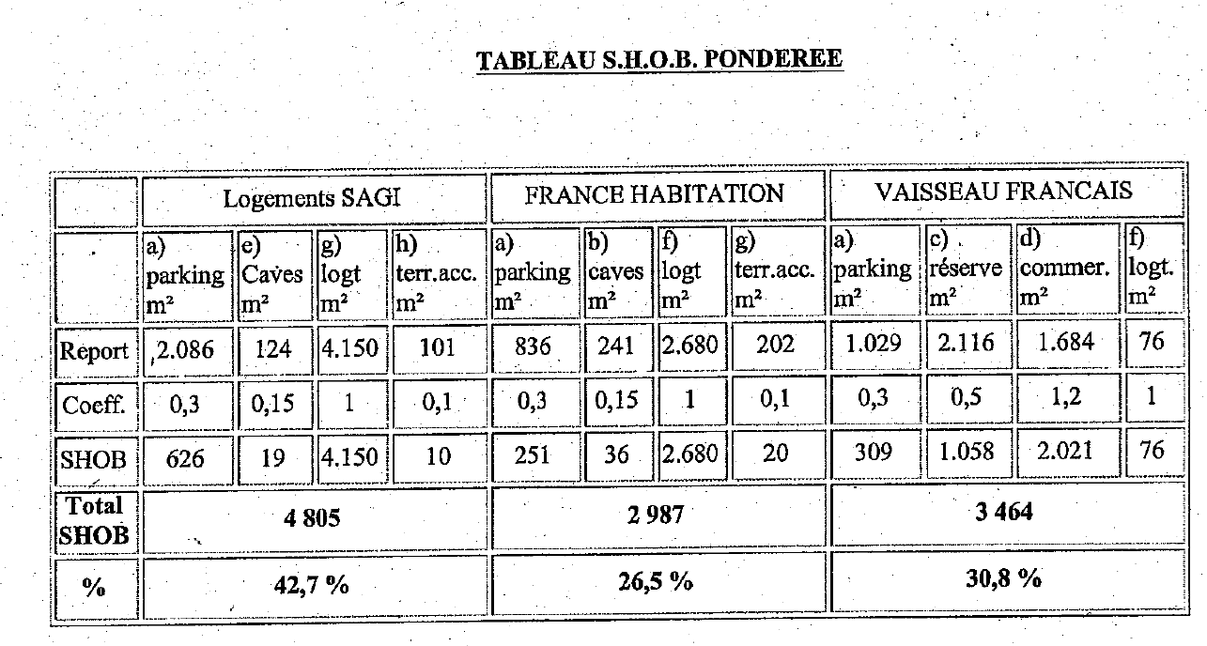

|  |  |  |  |
| --- | --- | --- | --- |
| RIVP (SAGI) | SEQENS (France Habitation) | SCI Michel THOMAS (Vaisseau Français) | Total M² |
| 4 150 | 2 680 | 76 | 6 906 |
| 60,09% | 38,81% | 1,1% |  |
|  |  |  |  |
| 4 150 + 10 | 2 680 + 20 | 2 021 + 76 | 8 957 |
| **46,44 %** | **30,14%** | **23,41%** |  |